ecological briefing note: Site 37 – CASTLE DOrE hillfort
List Entry: | 1006691 | Survey DAte: | 19/06/21 | Surveyors: | Woodfield Ecology
NGR: | SX 10352 54831 | what3words: | flown.spirit.equipment

- habitat survey
General Description of Site and Context
Monument comprises semi-improved grassland over a series of concentric ramparts and ditches located within stock-fenced enclosure. Grassland within the Survey Area appeared tightly-grazed by cattle (not present at time) and was species-poor, dominated by coarse grasses, except on the steeper banks and ramparts where the sward was shorter and more diverse. Scattered trees and scrub are present on most of the ramparts, and species-rich hedges from the field boundaries on the north and western sides. Rabbit Oryctolagus cuniculus activity was frequent in the hedgerows as well as on the ramparts where there were numerous Rabbit burrows and paths. Patches of bare ground were frequent across the monument, caused by Rabbit burrowing as well as erosion by cattle.
Habitat Survey Map
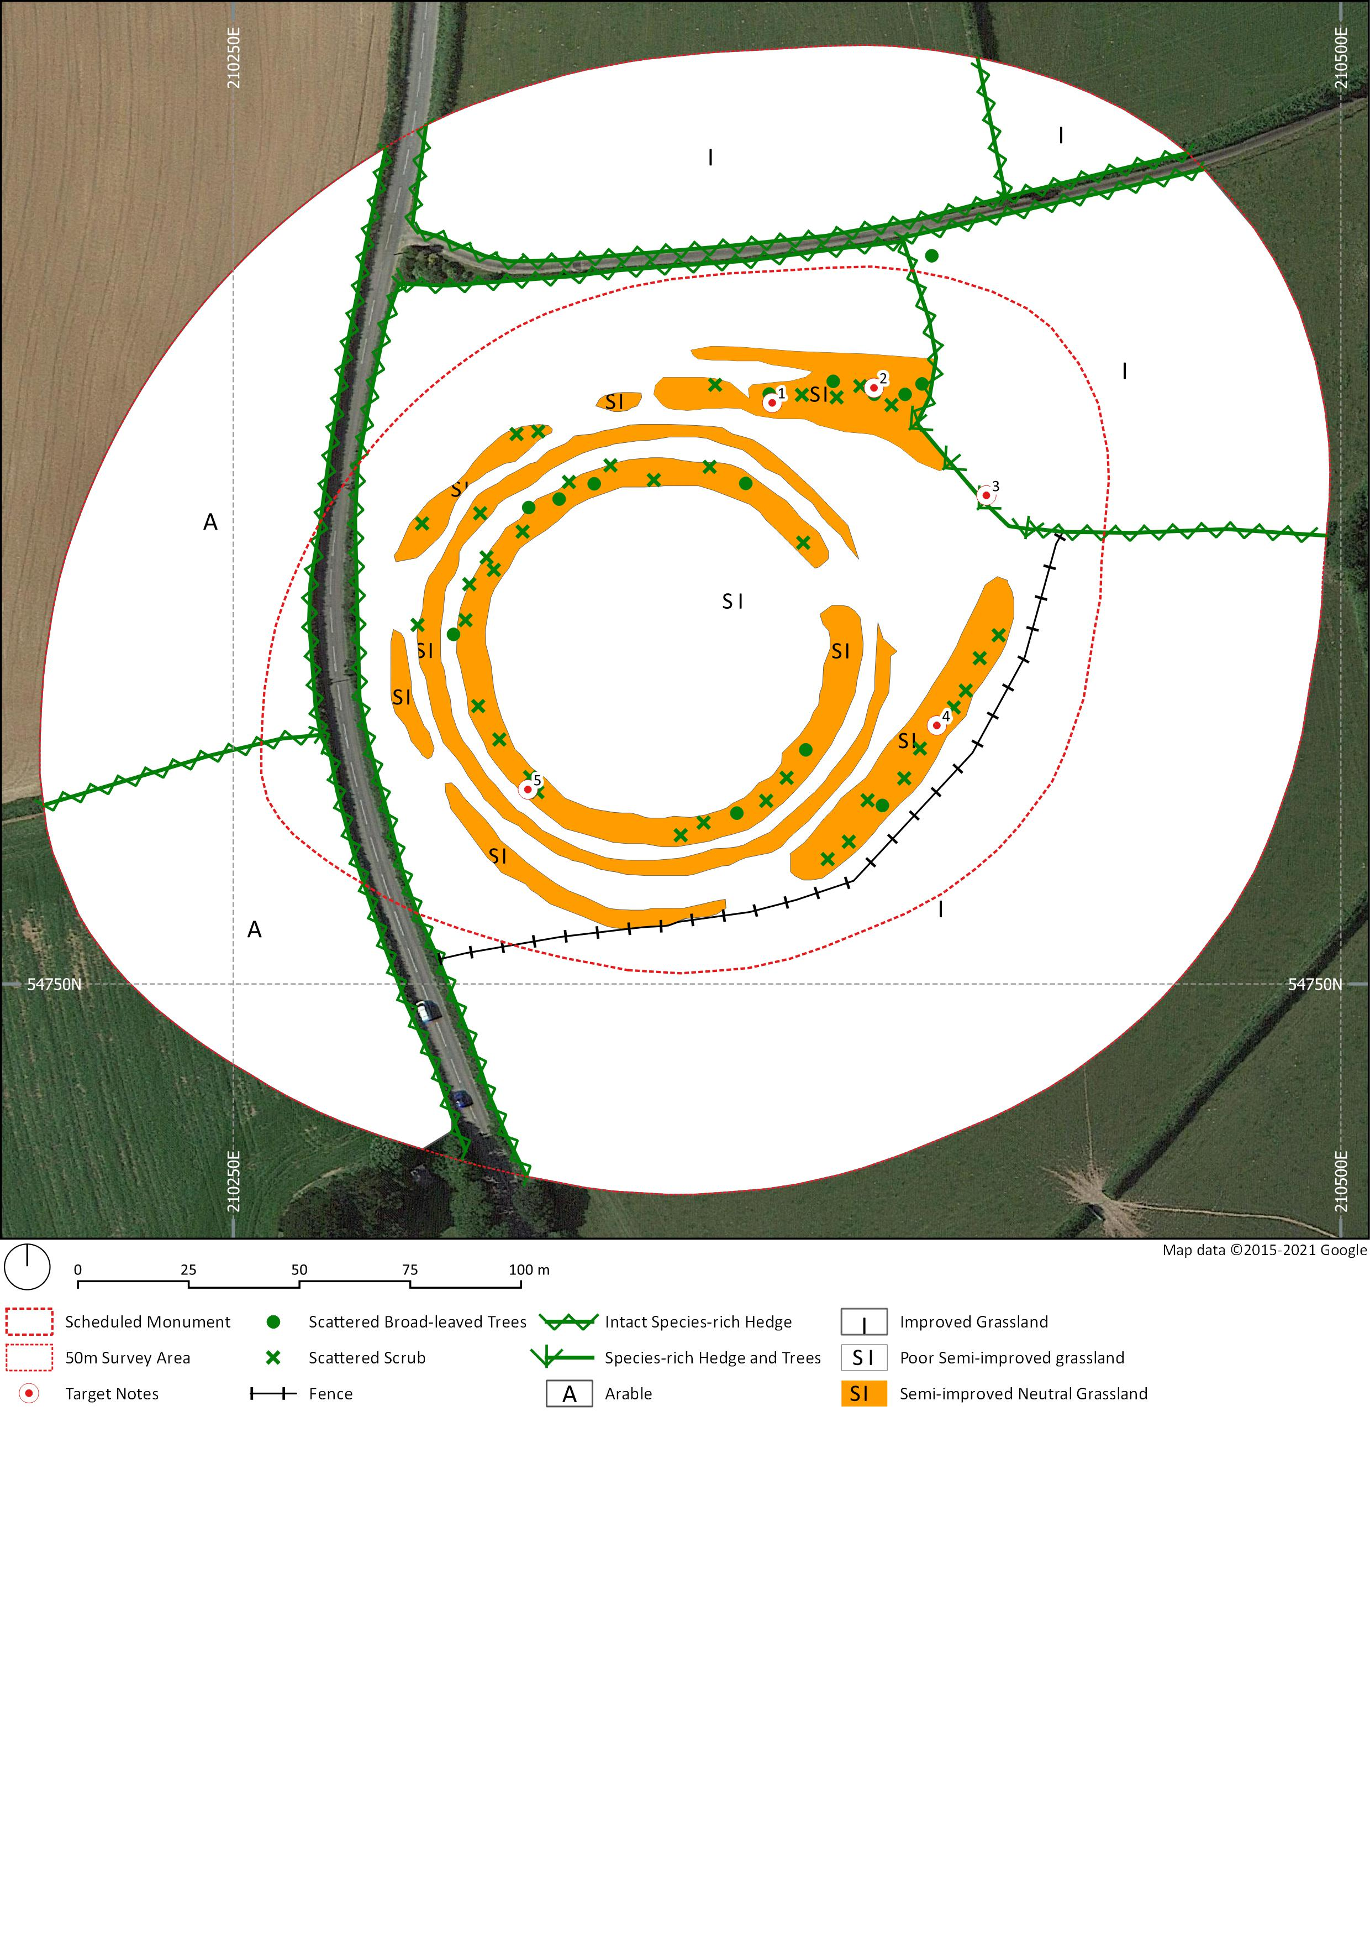

Target Notes
Ref. | Type | Notes
1 | Bats | Pedunculate Oak Quercus robur growing on top of outer rampart with several small knot holes and recently fallen dead branches. Considered to have low suitability for roosting bats.
2 | Bats | Hawthorn Crataegus monogyna covered in very dense ivy with thick-stemmed sections. Considered to have low suitability for roosting bats.
3 | Badger | Disused Badger Meles meles sett on the outer rampart. At least 4 entrances present large enough to have been used by Badgers, with many more smaller Rabbit burrows nearby. No evidence of current / recent use by Badger and Rabbit droppings found in the entrances of most.
4 | Rabbit | Extensive network of Rabbit burrows on the rampart, some burrows collapsed resulting in localised bare ground and erosion.
5 | Rabbit | Single large Rabbit burrow on the rampart, possibly previously a Badger sett based on shape and size, but no other evidence of Badger found and Rabbit droppings present inside.
Limitations & CAVEATS
No limitations were encountered during the survey with all areas fully accessible and readily viewed. It should be noted that whilst a comprehensive plant list (including notable species) was recorded, a detailed botanical assessment was beyond the scope of this survey.

- Ecological Features and Protection Status
Feature |  | within desk study area* (1km radius of Monument boundary) | within habitat survey area (50m radius of monument boundary)
Ecologically Designated Sites | Statutory Sites | None present | None present
 | Non-Statutory Sites | - Pinnock Wood CWS (600m)  - Lantyan, Woodgate & Penquite Woods CWS (890m) | None present
Important Habitats | Habitats of Principal Importance (HPIs) | - Deciduous woodland  - Traditional Orchard | The following HPIs were recorded within Survey Area:  - Hedgerows
 | Ancient Woodland | Ancient Replanted and Ancient Semi-natural Woodland present, the closest being Lawhibbet Wood c. 530m to the northeast. | None present
Protected and Notable Species | Bats | No records | No records within Survey Area.  Two trees (TN 1 & 2) within the monument boundary assessed to be of low suitability for roosting bats.
 | Dormouse | No records within 1km, however frequent records from surrounding 10km area. | No desk study records.  Hedgerows around the monument, and area of scattered scrub and trees on the northeast outer rampart are suitable for Dormice, although sub-optimal due to frequent hedgerow canopy gaps. Scattered scrub and trees elsewhere on monument ramparts not suitable due to lack of canopy connectivity.
 | Otter | No records | No desk study records.  No suitable habitat present.
 | Badger | No records | No desk study records.  Several possible disused sett entrances (now used by Rabbits), but no signs of current or recent presence.
 | Birds | Notable species:  - 1 nationally notable species: Skylark Alauda arvensis (SPI, Red List) | No desk study records.  Skylark (SPI, Red List) and Yellowhammer Emberiza citrinella (Red List) heard over Survey Area during site visit. Suitable nesting habitat within scattered trees and scrub and hedges, as well as for ground-nesting species on grassland covering the monument.
 | Reptiles | No records | No desk study records.  Moderate suitability around monument with south facing banks, however cover limited to small areas around scattered scrub due to intensive grazing.
 | Amphibians | No records | No desk study records.  No nearby water bodies.
 | Flora & Fungi | Notable species:  - 4 nationally notable plants (including 2 SPIs): Balm-leaved Figwort Scrophularia scorodonia, Wavy St John's-wort Hypericum undulatum: Welsh Poppy Papaver cambricum: Wild Cabbage Brassica oleracea var. oleracea  - 6 locally notable plants  - 2 nationally notable fungi | No desk study records.  Detailed botanical assessment beyond scope of survey, however no notable species found.
 | Invertebrates | - 22 nationally notable species (including 11 SPIs) | No desk study records.  Small areas of moderate value around monument ramparts and ditches and hedgerows with varied aspects and substrates, elsewhere only low / negligible value.
 | Invasive Plants | No desk study records obtained. | No desk study records obtained.  None found to be present.
* Desk study data obtained from Cornwall Biodiversity Network in June 2021. Only records <20 yrs old used in assessment.

- Potential Impacts & mitigation
Proposed ACtivities (taken from final archaeological report, august 2021)
Note: Activities not specifically listed below would require further ecological assessment
Site access | - Pedestrian access only.
Vegetation clearance (by hand) | - Carry out annual monitoring and scrub clearance with volunteer groups (e.g. CAS Area Reps, Truro College students).
Erosion repair (by hand) | - Repair erosion damage to ramparts. Initially this should be to four prioritised areas (P1 – P4, See report survey figs).
Temporary fencing | - Temporary fencing of the monument following erosion
Changes to grazing | - Discuss management of grazing regime with landowner/tenant.
Re-siting gate and water trough | - Re-site the water trough and adjacent gate to encourage cattle to graze away from the monument.
Non-invasive investigations / surveys | • Geophysical survey
Activity | feature | potential Impacts of proposed activities | Further survey and mitigation
Erosion repair, using hand tools | Reptiles | Killing / injury of reptiles as a result of erosion in-fill. | - Works should be undertaken at times of year when reptiles are active and able to disperse of their own accord, specifically April to October and when daytime temperatures >9°C.  - Any tall vegetation in the works area should be hand-searched for reptiles and cut short to a height of 150mm or less prior to any earthworks / infilling.  - Any reptiles found should be allowed to freely disperse into adjacent habitat.
 | Mammals | Killing / injury of wild animals as a result of infilling burrows | - While not a wildlife conservation issue, works must not result in deliberate cruelty to wild animals.  - Rabbit burrows should be re-checked in advance of works to determine whether they are disused before in-filling work occurs. If Rabbits remain present, they should be humanely controlled through use of approved techniques prior to erosion repair work commencing.
 | Habitats / flora | Importing inappropriate materials / seeds | - All soils brought to site for erosion repairs must be of a similar soil chemistry to that present, be low in nutrients and free of undesirable seeds. Local soils should be used if an appropriate source can be identified.
Scrub clearance, using hand tools | Breeding birds | Damage / destruction of active birds’ nests (ground-nesting species) within and around vegetation clearance area. | - Removal of scrub should be undertaken outside the main bird breeding season of March to August inclusive. If clearance of individual shrubs is necessary within the breeding season, a pre-clearance check (by trained volunteer) for the presence of nesting birds should be undertaken.
 | Bats | Killing / injury / disturbance of bats or damage / destruction of bat roosts | - Felling of the Pedunculate Oak (TN1) and Hawthorn (TN2) assessed to be of low suitability for bats should be undertaken with ecological supervision and using soft-felling techniques. (Note that both trees are also within an area of suitable Dormouse habitat – see below).
 | Dormouse | Killing / injury of dormice and loss of habitat | - A Dormouse nest tube survey should be undertaken if scrub clearance is planned for any hedges or the area of scrub on the northeast outer rampart which is connected to the surrounding hedge network.  - Dormouse survey is not considered necessary for the scattered scrub on the central ramparts and ditches as these are isolated from the hedgerow network and very unlikely to support Dormice even if present in peripheral areas.
Re-siting gate and water trough | Habitats | Loss of hedgerows | - The new gate and water trough should be located within a fenced boundary to avoid loss of hedges.  - Pipework for the re-sited water trough should also be routed in a way to avoid impacts to hedges and the root-zones of trees and shrubs.
 | Dormouse | Killing / injury of dormice and loss of habitat as a result of hedge removal. | - The new gate and water trough should be located within a fenced boundary to avoid loss of hedges.  - A Dormouse nest tube survey may be necessary if direct impacts to hedges would occur, depending on the size and location of any new hedge break.
 | Breeding birds | Damage / destruction of active birds’ nests as a result of hedge removal. | - The new gate and water trough should be located within a fenced boundary to avoid loss of hedges.  - If any individual shrubs require pruning / removal to facilitate the re-siting of the gate / water trough, this should either be undertaken outside of the bird breeding season or following a pre-clearance check (by trained volunteer) for the presence of nesting birds.
 | Reptiles | Killing / injury of reptiles as a result of hedge removal. | - Re-siting the gate and water trough within a fenced boundary would minimise potential impacts to reptiles.  - Any trenching work for water trough pipework should avoid direct impacts to hedges or hedgerow margins. If minor excavation work is required in these locations (e.g. to connect up to existing pipework) it should be undertaken at times of year when reptiles are active and able to disperse of their own accord, specifically April to October and when daytime temperatures >9°C.

- Further survey and mitigation calendar
Further Surveys | J | F | M | A | M | J | J | A | S | O | N | D
Dormouse survey | Dormouse nest-tube surveys involve monthly visits spread over most of the survey window.  Note – only required if scrub clearance proposed within hedges or habitats directly connected.
Mitigation |  | J | F | M | A | M | J | J | A | S | O | N | D
Breeding Birds | Avoid vegetation removal during the main nesting period, or undertake a pre-clearance check (by trained volunteer) for nesting birds
Dormouse | Work to confirmed Dormouse habitat will require a Natural England licence which will impose timing restrictions. | Timings pending results of further surveys and any licence requirements.
Reptiles | Avoid earthwork, erosion repair or removal of scrub roots and stumps during the hibernation period
key:
Optimal Periods for Survey
Periods when certain types of activity within suitable habitat for this species should be avoided or be subject to specific controls

- Enhancement Opportunities
Feature | Enhancement | Benefit
Invertebrates & Flora | Re-seed areas of bare ground and erosion repair with a locally appropriate species-rich grassland mix. Livestock should be excluded until established. | Improve botanical diversity with benefits for invertebrates through provision of wide range of larval food plants and variety of nectar sources.

Appendix 1: legal protection and statuses
Feature | Protection / Status | Relevant Legislation / source
ecologically Designated sites
Special Area of Conservation (SAC) | Selected to protect species and habitats listed on Annex I and II of the Habitats Directive. An ‘Appropriate Assessment’ is required for plans or projects likely to have a significant effect on a SAC. A plan or project with a likely significant effect, with no alternative solution, can only be undertaken if it is for imperative reasons of overriding public interest (IROPI). | Conservation of Habitats & Species Regulations 2017 (as amended)
Special Protection Area (SPA) | Selected to protect birds listed in Annex I of the Birds Directive, or certain migratory bird assemblages. An ‘Appropriate Assessment’ is required for plans or projects likely to have a significant effect on a SPA. A plan or project with a likely significant effect, with no alternative solution, can only be undertaken if it is for imperative reasons of overriding public interest (IROPI). | Conservation of Habitats & Species Regulations 2017 (as amended)
National Nature Reserve (NNR) | An NNR is an area which supports one of the best examples of a particular habitat in the nation. NNRs are given strict protection against damaging operations, and any such operations must in be authorised by the designating body (Natural England). NNRs must be managed for the purpose of research and study and / or for the preservation of such special features. | National Parks & Access to the Countryside Act (1949); Wildlife & Countryside Act 1981 (as amended)
Sites of Special Scientific Interest (SSSI) | Designated areas of special interest for their flora, fauna geological or physiographical features. Fully protected against intentional or reckless damage, disturbance or destruction. Certain activities that may likely damage a SSSI may only be carried out with consent from Natural England. Public bodies are not allowed to carry out damaging activities without notifying Natural England and must minimise damage and / or restore the SSSI to its previous state. Statutory authorities have a duty to further the conservation of SSSIs and must consult with Natural England where they propose activities that could affect a SSSI. | Wildlife & Countryside Act 1981 (as amended)
Local Nature Reserve (LNR) | Designated by Local Authorities through consultation with Natural England. LNRs may be given protection against damaging operations and have protections against development on and immediately around them. | National Parks & Access to the Countryside Act (1949)
County Wildlife Site (CWS) | In Cornwall, these are the most significant areas of semi-natural habitat outside of statutory protected sites. They are not legally protected, but through planning policy there is a presumption against development that would adversely affect a CWS. | Cornwall Local Plan 2010 - 2030.
Notable habitats
Habitats of Principal Importance (HPI) | The NERC Act, 2006 places a ‘Biodiversity Duty’ on Government (including local authorities and public bodies) to have regard for HPIs in the execution of their functions and on the Secretary of State to further promote the conservation of these habitats. | Natural Environment & Rural Communities (NERC) Act 2006
Ancient Woodland | Defined as areas that have been under continuous woodland cover since 1600, including ancient semi-natural woodland and plantations on ancient woodland sites. They are not legally protected, but through planning policy there is a presumption against development that would adversely affect an Ancient Woodland. | National Planning Policy Framework (NPPF)
Protected species
Bats | Bats are European Protected Species (EPS) and fully protected against killing, injury, disturbance, and against damage, destruction or obstruction of their resting places. | Conservation of Habitats & Species Regulations (2017);  Wildlife & Countryside Act 1981 (as amended)
Otter | Otters are an EPS and fully protected against killing, injury, disturbance, and against damage, destruction or obstruction of their resting places. | Conservation of Habitats & Species Regulations (2017);  Wildlife & Countryside Act 1981 (as amended)
Dormice | Dormice are an EPS and fully protected against killing, injury, disturbance, and against damage, destruction or obstruction of their resting places. | Conservation of Habitats & Species Regulations (2017);  Wildlife & Countryside Act 1981 (as amended)
Badgers | It is an offence to wilfully kill, injure, take, possess or cruelly ill-treat a Badger, or to attempt to do so; or to intentionally or recklessly interfere with a sett. | The Protection of Badgers Act, 1992
Reptiles | All reptiles are protected against intentional killing or injury. | Wildlife & Countryside Act 1981 (as amended)
Birds | All wild birds are protected (with the exception of species listed in Schedule 2 of the Act) against intentional or reckless killing or injury, and their nests are protected from damage or destruction while that nest is in use or being built. For certain species, listed on Schedule 1 (Sch1 WCA) it is also an offence to disturb the nest or dependant young. | Wildlife and Countryside Act 1981 (as amended)
Protected Flora | It is an offence to intentionally pick, uproot or destroy species of plant listed on Schedule 8 (Sch8 WCA). | Wildlife & Countryside Act 1981 (as amended)
Invasive Flora | It is illegal to plant or otherwise cause to grow any species listed on Schedule 9 in the wild (Sch9 WCA). | Wildlife & Countryside Act 1981 (as amended)
Notable species
Species of Principle Importance (SPI) | The NERC Act, 2006 places a ‘Biodiversity Duty’ on Government (including local authorities and public bodies) to have regard for SPIs in the execution of their functions and on the Secretary of State to further promote the conservation of these habitats. | Natural Environment & Rural Communities Act 2006
Nationally Notable Species | NS: Nationally Scarce: Occurring 16-100 10km squares in Britain.  NR: Nationally rare: Taxa occurring in 15 or fewer 10km squares in Britain. | -
Nationally Notable Invertebrates | Notable: Taxa thought to occur within the range of 16 to 100 10km squares or, for less-well recorded groups less than twenty vice-counties.  Notable-A: Taxa estimated to occur within 16-30 10-kilometre squares in Britain.  Notable-B: Taxa estimated to occur within 31-100 10 kilometre squares in Britain. | -
Nationally Notable Birds | Birds of Conservation Concern lists British birds as Green, Amber or Red indicating an increasing level of conservation concern. | Eaton, M.A., et al (2015) Birds of Conservation Concern 4: the population status of birds in the United Kingdom, Channel Islands and Isle of Man. British Birds 108: 708
Locally Notable Species  (CRBD) | Species listed in the second edition of the Cornish Red Data Book | Bennallick, I., et al. 2009. Red Data Book for Cornwall and the Isles of Scilly. 2nd Edition. Croceago Press. Praze-an-Beeble
Locally Notable Flora  (RPR) | RPR0: Species not seen recently (or presumed extinct).  RPR1: Cornwall Rare (in 1-3 tetrads).  RPR2: Cornwall Scarce (in 4-10 tetrads).  RPR3: Cornwall Local (in 11-20 tetrads). | Cornish Rare Plant Register (2013) Botanical Cornwall Group.
Appendix 2: BOTANICAL SPECIES LISTS
Habitat | Common Name | Latin Name | DAFOR*
Species-poor semi-improved grassland | Broad-leaved Dock | Rumex obtusifolius | O
 | Cock's-foot | Dactylis glomerata | O
 | Common Mouse-ear | Cerastium fontanum | R
 | Creeping Bent | Agrostis stolonifera | F
 | Creeping Buttercup | Ranunculus repens | O
 | Dandelion | Taraxacum officinale agg. | O
 | Perennial Rye-grass | Lolium perenne | D
 | Rough Meadow-grass | Poa trivialis | A
 | White Clover | Trifolium repens | F
Semi-improved neutral grassland | Cat's-ear | Hypochaeris radicata | A
 | Cock's-foot | Dactylis glomerata | R
 | Common Bent | Agrostis capillaris | A
 | Creeping Buttercup | Ranunculus repens | O
 | Early Dog-violet | Viola reichenbachiana | R
 | Foxglove | Digitalis purpurea | O
 | Hedge Bedstraw | Galium mollugo | R
 | Lesser Trefoil | Trifolium dubium | O
 | Marsh Thistle | Cirsium palustre | R
 | Perennial Rye-grass | Lolium perenne | O
 | Red Fescue | Festuca rubra | F
 | Ribwort Plantain | Plantago lanceolata | O
 | Sheep's Sorrel | Rumex acetosella | LF
 | Slender St John's-wort | Hypericum pulchrum | R
 | Spear Thistle | Cirsium vulgare | R
 | Sweet Vernal-grass | Anthoxanthum odoratum | A
 | White Clover | Trifolium repens | F
 | Wood Sage | Teucrium scorodonia | O
 | Yorkshire-fog | Holcus lanatus | O
Scattered scrub and broad-leaved trees | Bramble | Rubus fruticosus agg. | LF
 | Goat Willow | Salix caprea | R
 | Gorse | Ulex europaeus | O
 | Hawthorn | Crataegus monogyna | F
 | Holly | Ilex aquifolium | O
 | Pedunculate Oak | Quercus robur | R
Species-rich hedge | Atlantic Ivy | Hedera helix subsp. hibernica | F
 | Blackthorn | Prunus spinosa | R
 | Bluebell | Hyacinthoides non-scripta | F
 | Bracken | Pteridium aquilinum | A
 | Common Sorrel | Rumex acetosa subsp. acetosa | O
 | Creeping Soft-grass | Holcus mollis | A
 | Dog-rose | Rosa canina | R
 | Elder | Sambucus nigra | R
 | False Oat-grass | Arrhenatherum elatius | F
 | Greater Stitchwort | Stellaria holostea | O
 | Grey Willow | Salix cinerea subsp. cinerea | O
 | Ground-ivy | Glechoma hederacea | R
 | Hawthorn | Crataegus monogyna | O
 | Hazel | Corylus avellana | F
 | Hedge Bedstraw | Galium mollugo | O
 | Herb-Robert | Geranium robertianum | R
 | Holly | Ilex aquifolium | R
 | Honeysuckle | Lonicera periclymenum | O
 | Navelwort | Umbilicus rupestris | R
 | Pedunculate Oak | Quercus robur | F
 | Red Campion | Silene dioica | O
 | Scaly Male-fern | Dryopteris affinis | O
 | Wood Sage | Teucrium scorodonia | F
 | Yorkshire-fog | Holcus lanatus | O
Improved grassland | Cock's-foot | Dactylis glomerata | R
 | Common Bent | Agrostis capillaris | F
 | Dandelion | Taraxacum officinale agg. | O
 | Perennial Rye-grass | Lolium perenne | D
 | White Clover | Trifolium repens | O
*DAFOR scale: D = Dominant; A = Abundant, F = Frequent, O = Occasional, R = Rare. Prefix ‘L’= Locally

Appendix 3: Representative photos
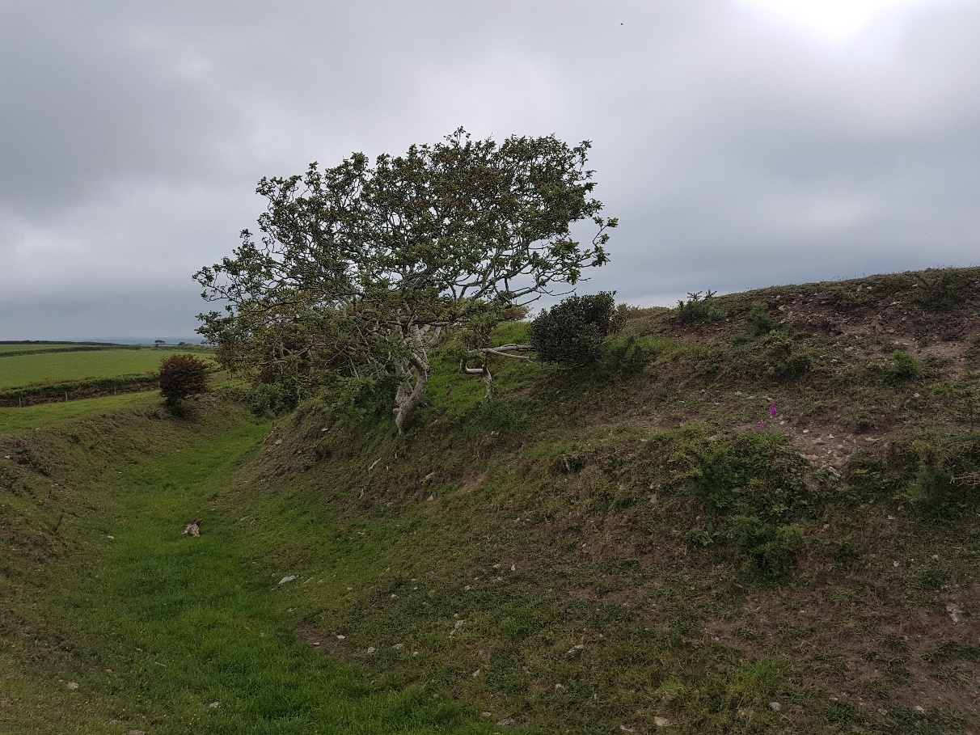
Scattered Holly and Gorse scrub on semi-improved grassland on ramparts
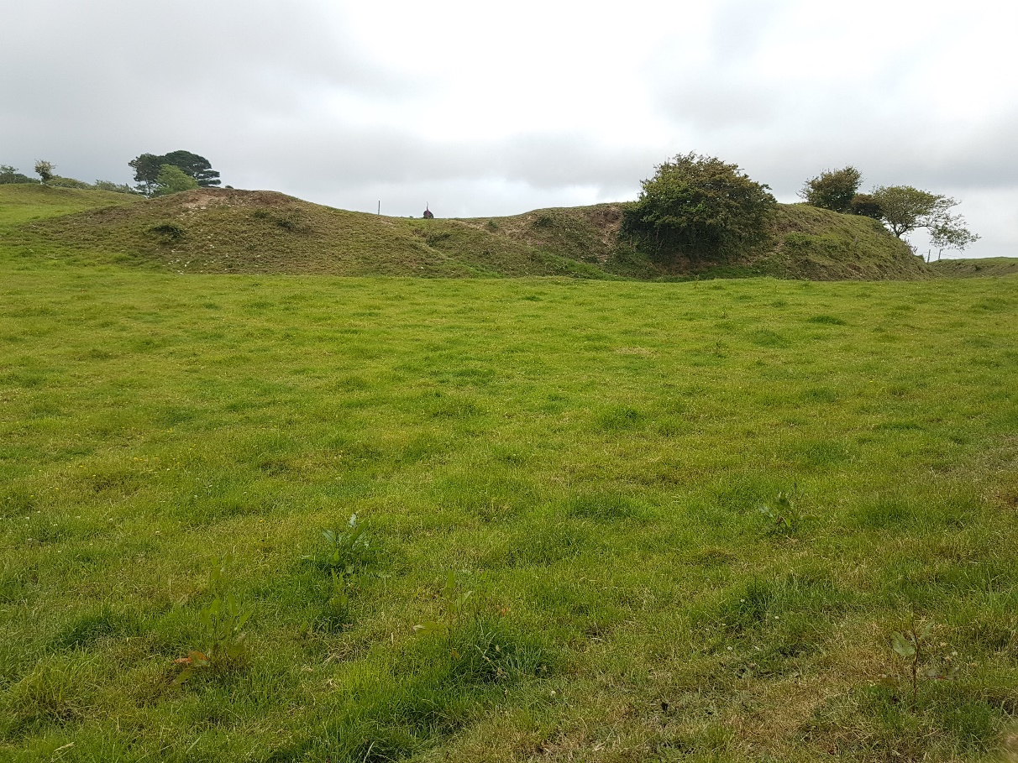
Species-poor semi-improved grassland in foreground with shorter and more diverse grassland on ramparts behind

